**Application running (com.galaxy.MerchantGuide)**

1. Choose file you would like pass as an input (only txt files are allowed)

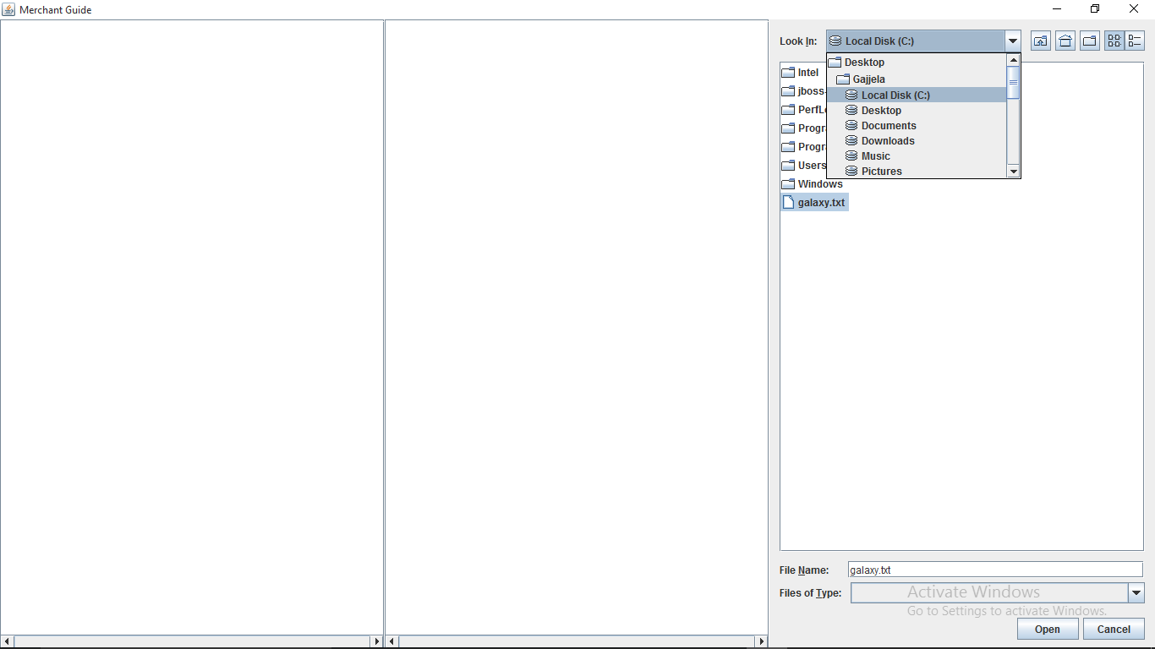

1. After selecting file the Interface will show the result.

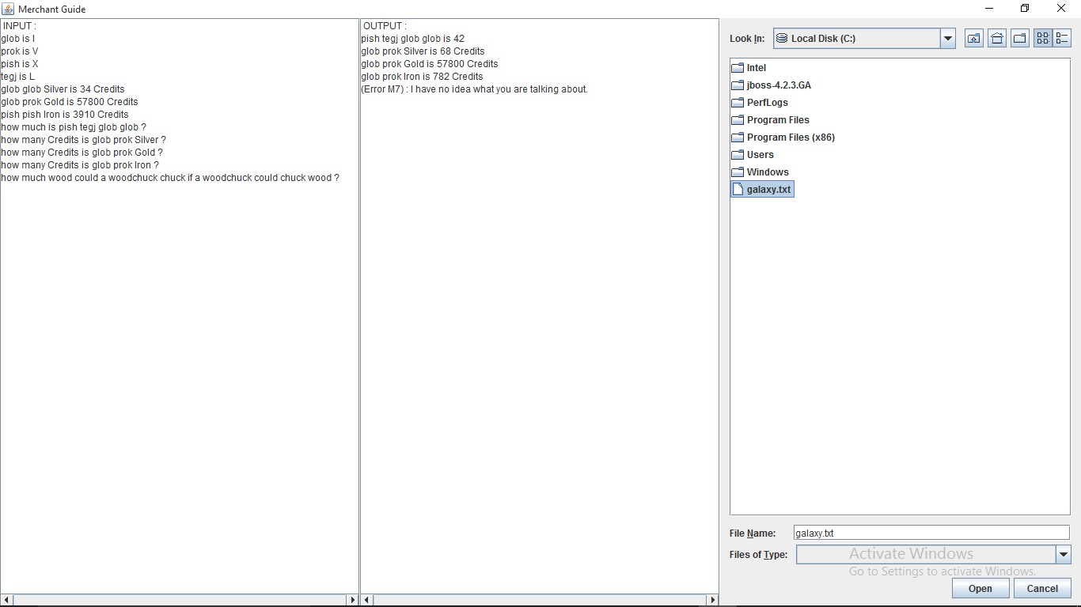

**Application flow  
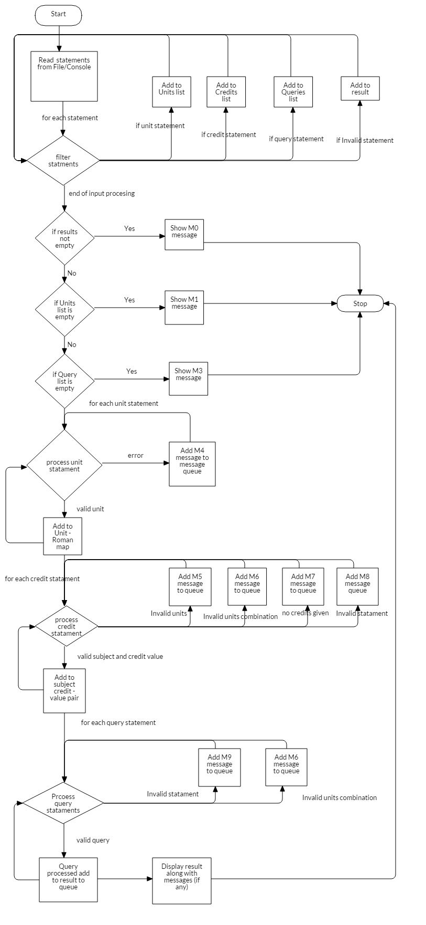**

The execution of the application will be as follows

1. An interface will be displayed for provision to choose file (only txt files)
2. After selecting file it will read line by line
3. Each line will matched as per the following patterns and separate lists prepared accordingly.

Type 1: Unit conversion pattern

Type 2: Credit value pattern

Type 3: Queries pattern

1. Type 1 list processed to create a Unit conversion mapping.
2. Type 2 list processed to create a Subject credit value using Unit conversion created in earlier step
3. Type 3 list processed using Unit conversion mapping and Subject credit mapping to prepare final result

Typical unit conversion output map (for the given assignment)

Glob = I

Prok = V

Pish = X

Tegj = L

Typical unit conversion output map (for the given assignment)

Silver = 17.0

Gold = 14450.0

Iron = 195.5

**Limitations and scope**

Merchant guide application expects the input in the following format only. Where in **[code]** is an actual unit used in galaxy and **[roman]** is the corresponding roman value, **[subject]** is the common metals or dirt as per given in the assignment, should be followed by given units and **[number of credits]** is the credit value given in the statements. The order of the statements will not matter, i.e. Input can start with any type (1, 2 or 3) of statements and can appear in between, later or before.

[Statement type 1: Unit conversion statements]

**[code_1]** is **[roman_1]**

**[code_2]** is **[roman_2]**

**[code_3]** is **[roman_3]**

.

.

**[code_n]** is **[roman_n]**

[Statement type 2: Credit value statements]

**[code_x] [code_y]**... **[code_n] [subject_1]** is **[number of credits]** Credits

**[code_x] [code_y]**... **[code_n] [subject_2]** is **[number of credits]** Credits

.

.

.

**[code_x] [code_y]**... **[code_n] [subject_n]** is **[number of credits]** Credits

[Statement type 3 Queries]

How much is **[code_x] [code_y]** **... [code_n]**?

How many Credits is **[code_x] [code_y]** **... [code_n] [subject_x]**?

How many Credits is **[code_x] [code_y]** **... [code_n] [subject_x]**?

How many Credits is **[code_x] [code_y]** **... [code_n] [subject_x]**?

How many Credits is **[code_x] [code_y]** **... [code_n] [subject_x]**?

**Invalid queries handling**

The below are the error messages displayed for different scenarios in this application.

|  |  |
| --- | --- |
| **Message No.** | **Message** |
| M0 | Cannot able to process the following statements, please provide at least one unit conversion data along with statements to process. |
| M1 | Please provide at least one unit conversion data along with statements to process. |
| M2 | Please provide at least one credit information. |
| M3 | No query statements to proceed. |
| M4 | Invalid conversion statement |
| M5 | The unit(s) provided in statement is/are invalid. |
| M6 | Invalid unit combination |
| M7 | Invalid or no credits given |
| M8 | Invalid credit statement |
| M9 | I have no idea what you are talking about. |

Class Diagram:

